EXPERIMENT.NO : 5
DATE : 13.2.2026
Name of the Experiment: Modeling of Swiggy Online Food Ordering System using UML
Aim:
To design and understand the working of the Swiggy Online Food Ordering System using UML Class Diagram and Sequence Diagram.
Software
- UML Drawing Software(SmartDraw)
System Description
The Swiggy system is an online platform that allows customers to order food from restaurants.
It provides features like menu display, online payment, order tracking, and invoice generation.
The system is divided into four main parts:
- Customer
- Swiggy Interface
- Order Server
- Swiggy Database
Each part has a specific role in order processing.
Class Diagram – Text Representation
Class: Customer
- Name : String
- PhoneNumber : String
- Address : String
Class: SwiggyInterface
- DisplayMenu()
- TrackOrder()
- ShowOffers()
- ProcessPayment()
- PrintInvoice()
Class: OrderServer
- FetchRestaurantDetails()
- ValidatePayment()
- AssignDeliveryPartner()
- CalculateETA()
Class: SwiggyDatabase
- VerifyUser()
- CheckInventory()
- LogOrderHistory()
- UpdateBalance()
Relationship Description
- Customer → SwiggyInterface (Uses)
- SwiggyInterface → OrderServer (Sends Request)
- OrderServer → SwiggyDatabase (Accesses Data)
This structure improves system performance and security.
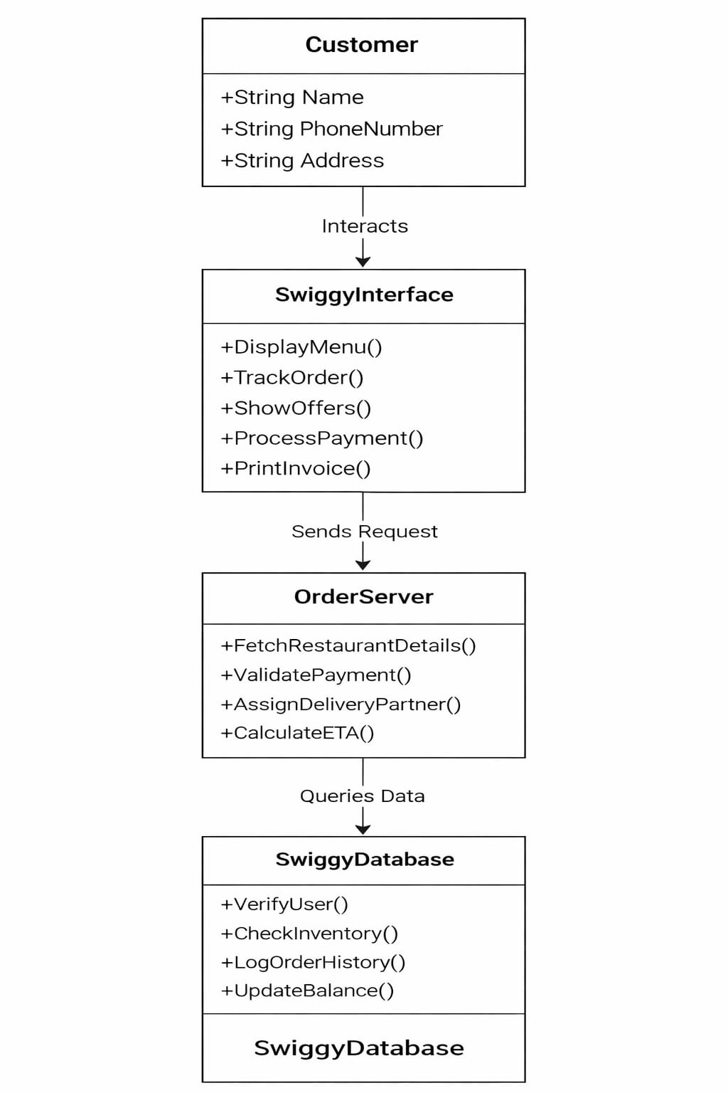

Sequence Diagram – Process Flow
Order Processing Steps:
- Customer opens the application
- Selects restaurant and food items
- Interface requests menu from server
- Server collects data from database
- Menu is shown to customer
- Customer confirms order
- Payment request is sent
- Database verifies account
- Payment is approved
- Order is stored
- Receipt is generated
- Order tracking starts
System Advantages
- Easy food ordering
- Secure payment system
- Fast processing
- Real-time tracking
- Digital invoice facility
Applications
- Online food delivery platforms
- Restaurant management systems
- E-commerce systems
- Mobile ordering apps
